Title: Analysing individual variation in predator hunting mode and the effect of predator and prey behavior on hunting success using an online multiplayer videogame

Article type: Major article

Word count: +/- 5919

List of main elements:

* Abstract
* Introduction
* Materials and methods
* Discussion
* Acknowledgements
* Funding
* Citing literature

Keywords: individual specialization, environmental variation, foraging mode, hunting tactics, predator-prey interactions, online videogames.

# Abstract

Predator-prey interactions are important drivers of community and ecosystem dynamics. In this study, we propose a novel system that uses an online multiplayer videogame to explore within-population variation in predator hunting mode, and how predator-prey behavioural interactions affect predator hunting success. We examined how travel speed, space coverage, ambush time, and latency to first capture correlate at three hierarchical levels (among environments, among individuals, and within individuals) to assess the structure of the predator hunting mode. We also investigated how these traits interact with prey travel speed and space coverage to affect predator hunting success. We found that individual predators specialized either as cursorial or ambush hunters along a continuum of these hunting traits, but also shifted their strategy between encounters. Predators were generally better against slower-moving prey, and both types of hunters achieved similar prey captures over the sampling period. Our study brings additional evidence that considering within-population variation in behavior and success during predator-prey interactions can increase our understanding of community stability. We further discuss the advantages and scientific insight that online videogames can provide for ecological research, and develop on their weaknesses and potential biases.

# Introduction

Predator hunting mode plays a crucial role in structuring ecological communities and ecosystems (Huey and Pianka 1981; Preisser et al. 2007; Schmitz 2008; Kersch‐Becker et al. 2018) and is usually described as 1) active/cursioral when hunters search, follow, and chase prey for long distances, 2) sit-and-pursue, when hunters remain motionless and pounce on prey that are within chasing distance, and 3) sit-and-wait/ambush, when hunters wait for prey to be within immediate capture distance (McLaughlin 1989). Field studies show that predators with contrasting hunting modes (e.g. cursorial vs ambush) differ in the number of individuals or species, or in the type of prey that they capture (Miller et al. 2014; Donihue 2016; Glaudas et al. 2019). As a result, they can cause opposing trophic cascades and act at different trophic levels (Schmitz 2008; Romero and Koricheva 2011).

Predator species tend to be classified either as active or sit-and-wait hunters based on their average behavior (Lima 2002; Miles et al. 2007; Pettorelli et al. 2015; Schmitz 2017). Despite that categorising predators is still useful to predict community and ecosystem dynamics (Wirsing et al. 2021), it essentially ignores the complexity of predator foraging decision-making. Growing evidence suggest that individual predator behavioral variation can exert important consequences for predator-prey interactions (Pettorelli et al. 2015; Toscano et al. 2016; Schmitz 2017). For instance, individual predator behavioral type can mediate consumptive and non-consumptive effects during trophic interactions (Smith and Blumstein 2010; Griffen et al. 2012; Toscano and Griffen 2014). Yet, the extent to which predators within populations differ in their foraging mode, and how these individual differences affect community and ecosystem processes remains unclear. It is therefore imperative that we account for individual variation in hunting mode during predator-prey interactions if we hope to understand the community consequences of predation.

Stable individual differences in hunting mode within populations can be driven by specialization when individuals experience temporal and/or spatial fluctuations in the distribution, availability, or behavior of their prey (Araújo et al. 2011; Carneiro et al. 2017; Phillips et al. 2017; Courbin et al. 2018). For instance, in marine predators, individuals specialize in specific tactics to meet the energy/time demands that are required to successfully capture the type of prey generally encountered (Bowen et al. 2002; Tinker et al. 2008; Arthur et al. 2016). Prey activity/mobility is an important trait influencing encounter rates with predators (Gerritsen and Strickler 1977; Huey and Pianka 1981; Scharf et al. 2006). Therefore, individual variation in encounter rates with prey activity-types may lead to nonrandom interactions between predator-prey behavioral types (Wolf and Weissing 2012). For example, the locomotor-crossover hypothesis (Huey and Pianka 1981) predicts that ambush predators should be more successful when they hunt fast-moving prey, while cursorial predators should have greater success with sedentary prey (Scharf et al. 2006; Belgrad and Griffen 2016; Donihue 2016). Individual predators with contrasting hunting modes might thus coexist within a population if their tactics allow them to reach similar capture rates (Kobler et al. 2009; Michel and Adams 2009; Chang et al. 2017).

Habitat structure is a second important driver of stable individual differences in predator foraging mode, as it shapes opportunities for prey encounter and prey capture (Robinson and Holmes 1982; James and Heck Jr. 1994; Sargeant et al. 2007; Wasiolka et al. 2009; Donihue 2016). A growing body of evidence points to predators who hunt in open and homogeneous habitats adopting a cursorial strategy, contrary to those hunting in heterogeneous and closed habitats that typically ambush their prey (James and Heck Jr. 1994; Wasiolka et al. 2009; Donihue 2016). Hence, the habitat components of a predator’s hunting grounds can shape its hunting tactic. Heterogeneous habitats are expected to favor sit-and-wait/sit-and-pursue hunters as they offer perches and cover, which are useful for ambushes (James and Heck Jr. 1994; Laurel and Brown 2006). On the contrary, active hunters should benefit from higher encounter rates in open habitats as prey detection is easier, although, at the expense of being themselves more easily detected (Michel and Adams 2009). This suggests that habitat structure could mediate tradeoffs between hunting strategies.

Trophic interactions are dynamic processes that can also trigger flexible behavioral adjustments by individual predators (Helfman 1990; Heithaus et al. 2018). For instance, predators can switch their hunting strategy in response to changes in prey density (Inoue and Marsura 1983), prey behavioral type (McGhee et al. 2013), prey condition (Wignall and Taylor 2008), seasonality (Miles et al. 2007; Phillips et al. 2017), or habitat structure (Wasiolka et al. 2009). Unfortunately, this type of research is often conducted under controlled laboratory conditions, which can fail to capture the nuances and complexities of a predator specie’s behavior in the wild (Carter et al. 2013; Niemelä and Dingemanse 2014). Empirically investigating individual variation in hunting mode requires repeated measures of behavior of numerous individuals under different environmental settings (Dall and Griffith 2014; Dingemanse and Wright 2020). Such an approach may impose considerable financial, technical, and ethical challenges when studying larger or elusive wildlife, such as apex predators (Hertel et al. 2020). An additional challenge in empirical studies of predator-prey interactions is identifying traits in predators and prey that are easily observable, but also ecologically relevant. For instance, foraging mode is expected to vary along a continuum of morphological, physiological, and behavioral traits (foraging syndrome hypothesis) (Perry et al. 1990; Perry 1999; Butler 2005; Cooper 2005; Miles et al. 2007), but few studies have investigated how habitat- and prey-specific characteristics jointly shape correlated foraging traits at different hierarchical levels.

Here, we propose a novel approach to circumvent these challenges by studying individual variation in predator behavior that capitalizes on online multiplayer videogames (Balicer 2007; Lofgren and Fefferman 2007; Oultram 2013; Ahmad et al. 2014; Ross et al. 2015). Online multiplayer videogames could provide numerous opportunities for ecologists to study general ecological phenomena, including the mechanisms driving individual variation in behavior (Barbe et al. 2020). First, online videogames provide abundant repeated measurements on millions of individual players across temporal and environmental gradients. Second, the structure of the virtual environment is known and can be used to evaluate how specific components affect the behavior of interest. Third, videogames can reproduce realistic ecological settings in which complex interactions occur among players. A classic example is the case of the “Corrupted Blood” epidemic in *World of Warcraft*, where transmission modes/vectors and human reactions to the disease were surprisingly similar to what would be expected in a real-world outbreak (Balicer 2007; Lofgren and Fefferman 2007). In this sense, online multiplayer videogames could potentially constitute a complement to traditional field studies. They could allow ecologists (among other scientists) to bridge the gap between real-world ecological studies and large-scale computer simulations (Cere et al., accepted, Ross et al. 2015).

We used the videogame *Dead by Daylight* (*DBD*) as our study system. *DBD* is an asymmetrical online multiplayer horror game that pits a single player (predator) against a group of four players (prey). The predator’s main objective is to search for and consume prey (figure 1A), whilst the preys’ objective is to exploit resources while avoiding the predator. These resources consist of generators that need to be repaired by the prey so they can escape and win. Prey can use a wide range of behaviors such as cooperation or hiding (Cere et al., accepted) to successfully escape (figure 1 B-C), which predators can exploit to lure them in an ambush. These situations offer the possibility for predators to express different hunting tactics. Moreover, each match in *DBD* occurs within a specific habitat, including forests, farmlands, and urban areas. These environments differ in the heterogeneity and complexity of their structures (McCoy and Bell 1991), such as in the availability of perches and refugia, vegetation density, or surface area (figure 1D). Hence, predators may encounter prey that express different behaviors, and are expected to benefit from changing their behavior accordingly to maximize hunting success.

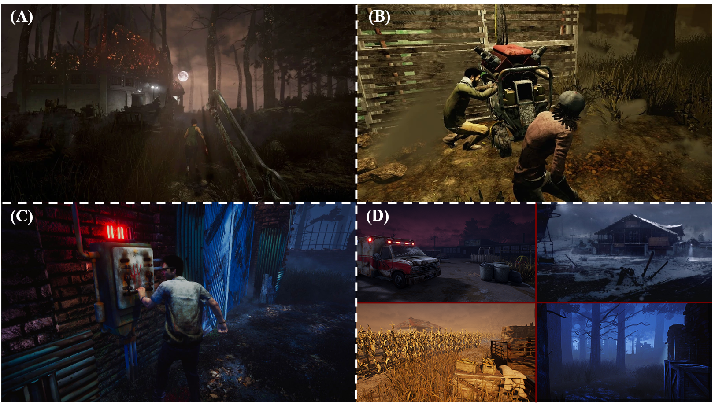

**Figure 1:** Images of the online videogame Dead by Daylight. (A) Image of the predator player’s first person vision. Here, we see a predator chasing a prey. (B) The prey (survivor) player’s third person vision. Prey can cooperate to repair generators. Once all generators are repaired, prey may activate one of the two escape doors in order to flee and win the match. (C) Representative image of a prey player activating an escape door. (D) Representative pictures of the different game environments where matches take place. The game environments settings vary between urban, farmland, and forest areas. All the images were taken from the official Dead by Daylight wiki and forum web pages (<https://deadbydaylight.fandom.com/wiki/Dead_by_Daylight_Wiki>, <https://forum.deadbydaylight.com/en/discussions>)

In this study, we use an extensive and complete dataset on the hunting behavior of predator players in *DBD* to investigate environmental and individual variation in hunting mode, and how predator and prey behavior affects prey capture. We use four hunting-related behaviors as proxies of hunting mode: travel speed, the rate of space covered in the environment, the proportion of time spent ambushing, and the time elapsed before the first prey capture. Predators adopting a cursorial hunting mode should travel faster and cover more space in the environment, while spending less time ambushing and having a shorter latency before the first capture. Predators with an ambush hunting mode should exhibit the opposite tendency. Thus, both strategies should represent the extremes of a continuum (Perry et al. 1990; Perry 1999; Butler 2005; Cooper 2005; Miles et al. 2007). We use multivariate mixed-modelling to quantify variation in these behaviors and their correlations as a way to decompose the hunting mode continuum at different hierarchical levels within the predator population (Dingemanse and Dochtermann 2013). These levels include among-environment differences in average hunting behavior, variation in hunting mode arising when individuals differ in their average hunting behavior (i.e. individual specialization), and variation arising from individuals adjusting their hunting mode over time in response to temporal changes in environmental conditions or prey behavior (i.e. individual flexibility). First, we hypothesize that habitats shape the hunting mode employed by predators. Therefore, we expect correlated trait values associated with an ambush mode in smaller and heterogeneous environments, and correlated trait values associated with a cursorial mode in open/wider and homogeneous environments (James and Heck Jr. 1994; Wasiolka et al. 2009; Donihue 2016). Second, we hypothesize that individual predators consistently differ in their hunting mode over time, with some specializing as cursorial hunters, and others as ambush hunters. Thus, we predict that individual predators will differ in their average trait values along a continuum for all hunting trait combinations (among-individual behavioral correlations). Third, we expect that individual predators express flexible hunting behavior by switching from cursorial to ambush tactics between foraging bouts (i.e. between matches). Thus, we predict that the individuals’ residuals in contrasting hunting behaviors (e.g. travel speed vs ambush time) will be negatively correlated (within-individual behavioral correlations). Lastly, following the locomotor-crossover hypothesis (Huey and Pianka 1981), we predict that ambush and cursorial predator-types will coexist in the population, because both achieve similar hunting success by performing better against prey with the opposite locomotor tendency.

# Materials and methods

## Study system

The datasets used to test our hypotheses were provided by Behaviour Interactive Inc., the owner and developer of *DBD*. The company records the behavior of players for every match played online. During our study period, *DBD* offered 15 playable predator avatars. Players who adopt the predator’s role choose their avatar before a match. Each predator avatar has unique abilities that may encourage different playstyles. Some have abilities that make them stealthier, while others can run faster, or have more powerful attacks. We thus controlled for the chosen avatar in our models since it may impact the playstyle of the predator player. In addition, the game environment where players compete is usually randomly assigned from a list of 27 maps differing in their physical components. For example, some maps have large playable surface areas with low vegetation density, which may favor the use of a cursorial strategy. Other maps have a smaller surface area with high vegetation density, which may impair visibility and alter prey detection, favoring the use of an ambush strategy. For additional details on the game settings and map characteristics, refer to <https://deadbydaylight.com/en>, and <https://deadbydaylight.gamepedia.com/Dead_by_Daylight_Wiki>.

## Data collection

The study period ranged from 20 March to 17 June 2019. Our population consisted of 2 171 new anonymous players who initiated their first match between 20 March and 22 March, with a total record of 70 831 matches (average: 177 matches per individual, range: 1 - 972 matches). The average match duration was 11 minutes (range: 5 - 58 minutes). For each match, we recorded the date (date-hour-minutes), the duration, the predator player’s anonymous ID, the prey players’ anonymous ID’s, the predator’s avatar, and the game environment where the match took place. We also recorded predator and prey behavior. We retained matches that lasted more than 5 minutes (short matches are usually interrupted because of technical issues). Players also score points during a match by performing different actions. To control for matches where players did not play, or for errors in the data collection, we removed matches where predators earned less than 1 point.

## Behavioral traits

We selected four out of eight behavioral variables that summarized most of the variation in predator hunting tactics based on a principal component analysis (see figure S1 and table S1 in the Supporting information): average travel speed (m/s), the rate of space covered (square/s), the proportion of time spent ambushing over the match duration, and the proportion of time predators took to capture their first prey over the match duration. We quantified the predator’s average travel speed as the average number of meters per second traveled during a match. Space coverage describes the number of 16x16 meters squares (from a grid that covers the whole virtual environment) entered per second in the environment (similar to the open field test, Montiglio et al. 2010). These grids are drawn by the videogame developer to build the game environments, but are invisible to the players. Unfortunately, it was not possible to know which specific square was visited. Based on this data, we could divide the number of times a square was visited by the match duration to obtain the rate of space covered. The proportion of time spent ambushing describes the total amount of time a predator spent monitoring around capture sites to ambush prey that try to rescue a conspecific. We quantified this trait with help from the developer who drew (invisible) circles of 9-meter radiuses around all sites where the predator brought prey to be consumed (each site is at the center of a circle). Predators in *DBD* monitor these sites to ambush prey that come rescue their captured conspecifics. Thus, each time a predator brought prey to a site during a match, the time (in seconds) it spent monitoring inside the area of a circle was recorded. We could then sum the total amount of time spent ambushing during a match and divide it by the match duration (in seconds) to have the proportion of time spent ambushing over the match duration. Lastly, the time before the first capture was calculated as the amount of seconds elapsed before a predator consumed his first prey, divided by the match duration.

We quantified prey average travel speed (m/s) and rate of space covered (square/s). These two traits were measured using the same method described for predators. For both traits, we averaged the four individual prey values within each match since we were interested in the average effect of prey behavior on the predator’s hunting behavior and success. Thus, we used one average value per prey trait, for each match played.

## Statistical analyses : Software and computer setup

We performed all statistical analyses using the R software (version 4.0.2, R Core Team, 2020) on a remote computer cluster (Cedar, Compute Canada, <https://docs.computecanada.ca/wiki/Cedar>) running on CentOS Linux 7. All models were fitted using the R package “brms” version 2.14.4 (Bürkner 2017). We provide the R code and outputs on this GitHub repository (<https://github.com/quantitative-ecologist/videogame_hunting_tactics-Rscripts>) with the R sessions information to ensure reproducibility.

## Statistical analyses: Variation in hunting mode

We first parametrized a multivariate Bayesian mixed model to quantify unadjusted repeatability of hunting behavior, and evaluate among-environment, among-individual (specialization), and within-individual (flexibility) behavioral correlations. We included the predator’s population-response to prey behavior by adding prey travel speed ($x_{1}$) and rate of space covered ($x_{2}$) as linear fixed effects. We square-root transformed the four hunting behaviors ( $y1$ = speed, $y2$ = space, $y3$ = ambush time, $y4$ = time 1st capture) to achieve normality and then defined each as having a Gaussian distribution. All traits were then standardized to mean and unit variance (z-scores). The model is described by the following equations:

$$\begin{matrix}y1_{ij} & = (β_{0y1}+id_{0y1,i}+env_{0y1,i}+avatar_{0y1,i}) \\ & + β_{1y1}x_{1}+β_{2y1}x_{2}+ε_{0y1,ij}\end{matrix}$$

$$\begin{matrix}y2_{ij} & = (β_{0y2}+id_{0y2,i}+env_{0y2,i}+avatar_{0y2,i}) \\ & + β_{1y2}x_{1}+β_{2y2}x_{2}+ε_{0y2,ij}\end{matrix}$$

$$\begin{matrix}y3_{ij} & = (β_{0y3}+id_{0y3,i}+env_{0y3,i}+avatar_{0y3,i}) \\ & + β_{1y3}x_{1}+β_{2y3}x_{2}+ε_{0y3,ij}\end{matrix}$$

$$\begin{matrix}y4_{ij} & = (β_{0y4}+id_{0y4,i}+env_{0y4,i}+avatar_{0y4,i}) \\ & + β_{1y4}x_{1}+β_{2y4}x_{2}+ε_{0y4,ij}\end{matrix}$$

where *g* indexes the environment, *h* the predator avatar, *i* the individual player, and *j* the recorded match. The game environment ($env_{0y,g}$), the predator avatar ($avatar_{0y,h}$), and the player ID ($id_{0y,i}$) are random intercepts (among- environment, avatar, and individual variances), and ($ε_{0y,ghij}$) are the residuals (within-individual variance). Random intercepts and residuals were assumed to follow a multivariate Gaussian distribution with their associated variance-covariance matrixes ($Ω_{env}$, $Ω_{avatar}$, $Ω_{id}$, $Ω_{ε}$) (equations S1-S4 in the Supporting information). For each combination of behaviors ($y_{n}$), we extracted the behavioral correlations among- environments ($r_{env_{0,y_{n}}env_{0,y_{n}}}$), avatars ($r_{avatar_{0,y_{n}}avatar_{0,y_{n}}}$), and individuals ($r_{id_{0,y_{n}}id_{0,y_{n}}}$), as well as within-individual behavioral correlations ($r_{ε_{0,y_{n}}ε_{0,y_{n}}}$) (Dingemanse and Dochtermann 2013). The sample size of each parameter’s posterior distribution is 4000 (see section ‘Parametrization of the Bayesian multivariate mixed model’ in the Supporting information for details).

Following Nakagawa and Schielzeth (2010), we calculated each hunting trait’s adjusted repeatability estimate (intra-class correlation coefficient, *ICC*) for the game environment, the predator avatar, and the player ID, by dividing the variance of the specific random effect by the total phenotypic variance (e.g. $ICC_{id_{y1}}=V_{id_{0,y1}}/(V_{env_{0,y1}}+V_{avatar_{0,y1}}+V_{id_{0,y1}}+V_{ε_{0,y1}})$ ). We computed the 95% credible intervals for each repeatability estimate using the highest posterior density intervals.

## Statistical analyses: Effect of hunting behaviour and prey behaviour on prey capture

Since predators can capture a maximum of four prey, we used the number of prey captured per total number of prey in a match (four) as a binomial response variable ( $ω_{hij}$ ~ $Binom(max_{hij},P_{hij})$). We first quantified the linear relationship between hunting success and predator behavior by fitting a binomial Bayesian generalized linear mixed model with a logit link function. The model fits a linear function ($β_{n,pred}{\text{x}}_{hi}$) where we could estimate if hunting success increased or decreased with increasing hunting behavior scores. We fitted the mean probability of capturing four prey ($P_{hij}$) in the environment *h* for individual *i* on its *j* match as a function of its travel speed, rate of space covered, proportion of time spent ambushing, and proportion of time before the first capture (equation S5 in the Supporting information). We computed a second model to account for variation in hunting success explained by prey behavior ($β_{n,prey}{\text{x}}_{hi}^{′}$). We thus added prey travel speed and their rate of space covered in the model equation (equation S6 in the Supporting information). Both models had random intercepts for the game environment ($env_{0,h}$) and the predator player’s ID ($id_{0,i}$) to partition the variance in hunting success explained by differences among players and the environments where matches occurred. The random intercepts for the game environment and the player ID were assumed to follow a Gaussian distribution with estimated variance ($env_{0,h}$ ~ $N(0,V_{env})$, $id_{0,i}$ ~ $N(0,V_{id})$). We included an observation-level random effect to account for overdispersion and compared the models to a beta-binomial model to ensure that the estimates were robust (Harrison 2015). Trait values were standardized to mean and unit variance (z-scores). The sample size of each parameter’s posterior distribution is 4000 for the first model and 6000 for the second model.

We built a third model with the same structure as the first model and included quadratic terms ($\frac{1}{2}γ_{n,pred}{\text{x}}_{hi}$) to determine whether the relationships between hunting success and predator behavior are concave or convex (equation S7 in the Supporting information). Concave gradients suggest that individuals at the extremes of the trait distribution perform poorly while the opposite is true when the gradient is convex (Brodie et al. 1995). We also added interaction terms for each combination of predator traits ($γ_{n,pred}$) to estimate correlated effects on hunting success. Lastly, we computed a fourth model with the same structure as the third and included quadratic terms for prey behavior ($\frac{1}{2}γ_{n,prey}{\text{x}}_{hi}^{′}$), and interaction terms between predator and prey behaviors ($γ_{n,\text{pred prey}}$) to test if predators perform better against prey with the opposite locomotor tendency (locomotor crossover) (equation S8 in the Supporting information). All trait values were standardized to mean of 0 and unit variance (z-scores). The sample size of each parameter’s posterior distribution is 4000 for both models.

We calculated the models’ *ICCs* following Nakagawa et al. (2017). For each model parameter, we computed the 95% credible intervals using the highest posterior density intervals. We assumed that the fixed effects and the *ICCs* reached statistical significance when their respective 95% credible intervals did not overlap zero (Nakagawa and Cuthill 2007).

# Results

## Variation in hunting mode: Repeatability of hunting behaviour

Contrary to our predictions, neither the average travel speed ( $ICC_{env_{y1}}$ [95% CI] = 0.002 [0.001, 0.003]), nor the proportion of time spent ambushing ( $ICC_{env_{y3}}$ [95% CI] = 0.002 [0.001, 0.003]) differed among the game environments (figure 2B, diagonal). We detected small differences among the game environments in the average rate of space covered ( $ICC_{env_{y2}}$ [95% CI] = 0.065 [0.036, 0.097]) and time before the first capture ( $ICC_{env_{y4}}$ [95% CI] = 0.055 [0.029, 0.082]) (figure 2B, diagonal).

Predator avatars differed slightly in their average travel speed ( $ICC_{avatar_{y1}}$ [95% CI] = 0.091 [0.042, 0.153]. Predators displayed weak differences between the avatars for the other three hunting behaviors ( $ICC_{avatar_{y2}}$ [95% CI] = 0.025 [0.010, 0.046], $ICC_{avatar_{y3}}$ [95% CI] = 0.034 [0.012, 0.064], $ICC_{avatar_{y4}}$ [95% CI] = 0.021 [0.008, 0.039]).

As predicted, we found moderate among-individual differences in average travel speed ( $ICC_{id_{y1}}$ [95% CI] = 0.280 [0.254, 0.304]) and average proportion of time spent ambushing ( $ICC_{id_{y3}}$ [95% CI] = 0.322 [0.301, 0.342]), while individuals differed weakly in their time before the first capture ( $ICC_{id_{y4}}$ [95% CI] = 0.102 [0.091, 0.114]) (figure 2A, diagonal). Individual predators differed weakly in their average rate of space covered ( $ICC_{id_{y2}}$ [95% CI] = 0.051 [0.044, 0.057]) (figure 2A, diagonal).

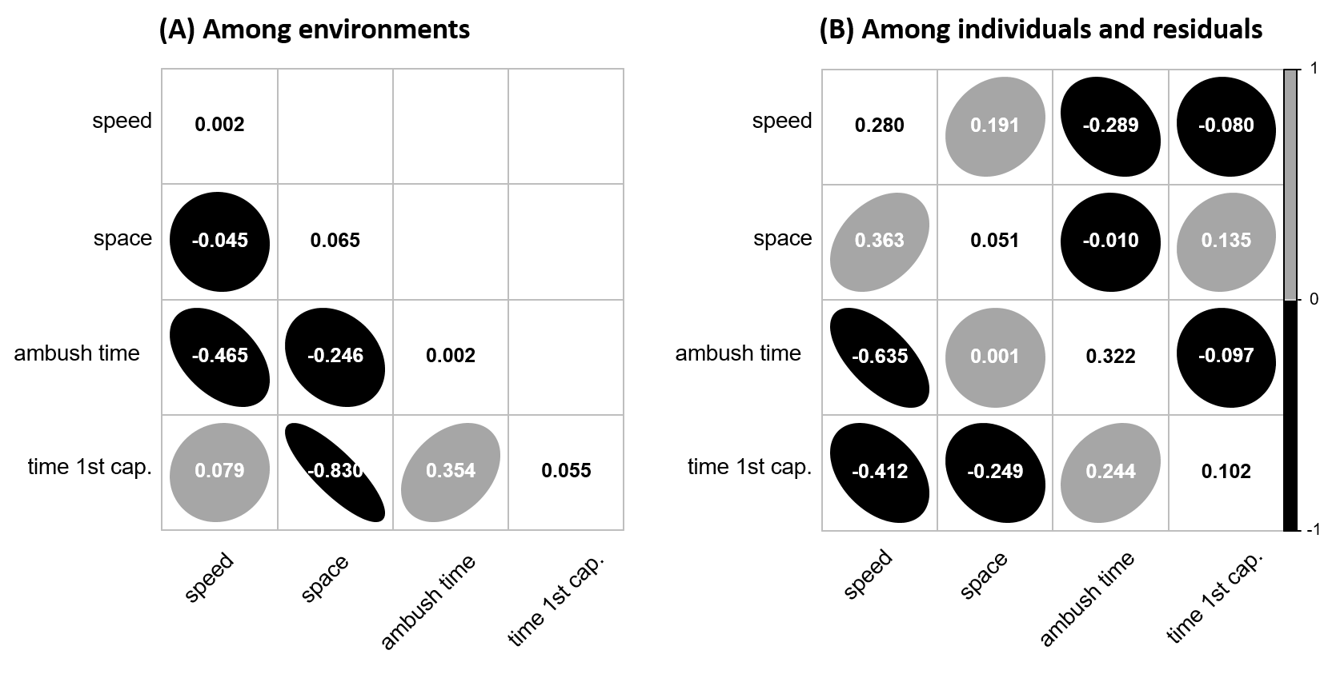

**Figure 2:** Correlations between combinations of hunting behaviors and their *ICCs*. For each panel, the *ICC* of trait is displayed on the diagonal. Black and gray circles are negative and positive correlations respectively. (A) Among-environment behavioral correlations on the lower off-diagonal. (B) Among-individual behavioral correlations on the lower off-diagonal, and residual within-individual behavioral correlations on the upper off-diagonal. Behavior names were shortened to simplify the plot.

## Variation in hunting mode: Correlations between hunting behaviours

Environments where predators were on average faster were also also those where they spent on average less time ambushing their prey ( $r_{env_{0,y1}env_{0,y3}}$ [95% CI] = -0.465 [-0.767, -0.143]) (figure 2A, lower off-diagonal). We detected a similar relationship between space coverage and time spent ambushing, although it was not statistically significant as the credible intervals overlapped zero ( $r_{env_{0,y2}env_{0,y3}}$ [95% CI] = -0.246 [-0.582, 0.071]). Predators took on average less time to capture their first prey in environments where they covered space at a faster rate ( $r_{env_{0,y2}env_{0,y4}}$ [95% CI] = -0.830 [-0.937, -0.702]), while taking more time on average in environments where they used ambushes ( $r_{env_{0,y3}env_{0,y4}}$ [95% CI] = 0.354 [0.025, 0.650]) (figure 2A, lower off-diagonal). Lastly, we did not detect among-environment correlations between travel speed and space coverage, or between travel speed and the time before capturing a first prey ( $r_{env_{0,y1}env_{0,y2}}$ [95% CI] = -0.045 [-0.404, 0.291], ( $r_{env_{0,y1}env_{0,y4}}$ [95% CI] = 0.079 [-0.273, 0.419]) (figure 2A, lower off-diagonal).

As we expected, the predators’ average travel speed and proportion of time spent ambushing were negatively correlated ( $r_{id_{0,y1}id_{0,y3}}$ [95% CI] = -0.635 [-0.671, -0.597]). Thus, faster predators spent less time ambushing prey (figure 2B, lower off-diagonal). Faster individuals covered space at a faster rate ( $r_{id_{0,y1}id_{0,y2}}$ [95% CI] = 0.363 [0.297, 0.434]), and individuals who were faster or covered space at a faster rate also took less time to capture their first prey ( $r_{id_{0,y1}id_{0,y4}}$ [95% CI] = -0.412 [-0.470, -0.350], $r_{id_{0,y2}id_{0,y4}}$ [95% CI] = -0.249 [-0.331, -0.163]) (figure 2B, lower off-diagonal). There was no relationship between space covered and time spent ambushing ( $r_{id_{0,y2}id_{0,y3}}$ [95% CI] = 0.001 [-0.075, 0.079]), but ambush hunters required more time to capture their first prey ( $r_{id_{0,y3}id_{0,y4}}$ [95% CI] = 0.244 [0.177, 0.310]) (figure 2B, lower off-diagonal).

At the residual within-individual level, we detected a weak positive correlation between travel speed and the rate of space covered ( $r_{ε_{0,y1}ε_{0,y2}}$ [95% CI] = 0.191 [0.184, 0.198]) and a negative correlation between travel speed and the proportion of time spent ambushing prey ( $r_{ε_{0,y1}ε_{0,y3}}$ [95% CI] = -0.289 [-0.296, -0.282]) (figure 2B, upper off-diagonal). Hence, matches in which a predator was faster (relative to its average) were also matches in which it covered space at a faster rate, while spending less time ambushing prey. Predators that covered space at a faster rate also took more time before capturing their first prey ( $r_{ε_{0,y2}ε_{0,y4}}$ [95% CI] = 0.135 [0.127, 0.142]) (figure 2B upper off-diagonal). We did not detect large correlations between travel speed or time spent ambushing and the time before the first capture ( $r_{ε_{0,y1}ε_{0,y4}}$ [95% CI] = -0.080 [-0.088, -0.073], $r_{ε_{0,y3}ε_{0,y4}}$ [95% CI] = -0.097 [-0.105, -0.090]).

## Effect of predator and prey behaviour on hunting success: Linear relationships

Predator behavior alone (equation S5) explained 12.7% of the variation in hunting success ( $R_{marginal}^{2}$ = 0.127). Travel speed and time spent ambushing were positively related to hunting success (table I), suggesting that faster predators and ambush predators captured more prey (figure 3A, C). Predators who covered space at a faster rate captured fewer prey (table I) (figure 3B). Predators that required more time to capture their first prey had lower hunting success (table I) (figure 4D). Hunting success barely varied among game environments ( $ICC_{env}$ [95% CI] = 0.005 [0.002, 0.008]). Differences among individuals in hunting success were low ( $ICC_{id}$ [95% CI] = 0.067 [0.060, 0.074]).

Adding prey behavior (equation S6) increased the explained variance in hunting success to 18% ( $R_{marginal}^{2}$ = 0.181). Predators that competed against cursorial prey had significantly lower hunting success (table I). Prey that were faster at covering space in the environment significantly reduced the predators’ hunting success (table I).

Table 1: Estimates of the models relating predator hunting success to predator hunting behavior, prey behavior, and their interactions.

|  | Linear (95% CI) | Quadratic (95% CI) | Pred Interaction (95% CI) | Pred-prey Interaction (95% CI) |
| --- | --- | --- | --- | --- |
| speed | 0.07 ( 0.05, 0.08) | -0.11 (-0.10, -0.12) | - | - |
| space | -0.40 (-0.38, -0.42) | 0.09 ( 0.08, 0.10) | - | - |
| ambush | 0.38 ( 0.37, 0.40) | -0.12 (-0.12, -0.13) | - | - |
| time | -0.66 (-0.64, -0.67) | 0.13 ( 0.12, 0.14) | - | - |
| prey speed | -0.20 (-0.19, -0.22) | -0.07 (-0.07, -0.08) | - | - |
| prey space | -0.63 (-0.60, -0.65) | -0.10 (-0.08, -0.11) | - | - |
| speed:space | - | - | -0.06 (-0.04, -0.07) | - |
| speed:ambush | - | - | -0.11 (-0.09, -0.12) | - |
| speed:time | - | - | -0.06 (-0.04, -0.07) | - |
| space:ambush | - | - | 0.04 ( 0.03, 0.06) | - |
| space:time | - | - | -0.03 (-0.02, -0.05) | - |
| ambush:time | - | - | -0.02 (-0.01, -0.04) | - |
| speed:prey speed | - | - | - | -0.01 (-0.03, 0.00) |
| speed:prey space | - | - | - | -0.09 (-0.07, -0.12) |
| space:prey space | - | - | - | -0.05 (-0.03, -0.06) |
| space:prey space | - | - | - | 0.10 ( 0.07, 0.12) |
| ambush:prey speed | - | - | - | -0.06 (-0.04, -0.07) |
| ambush:prey space | - | - | - | -0.01 (-0.03, 0.01) |
| time:prey speed | - | - | - | 0.00 (-0.02, 0.01) |
| time:prey space | - | - | - | 0.05 ( 0.03, 0.07) |

## Effect of predator and prey behaviour on hunting success: Quadratic relationships

Relative to the first model, the model that included quadratic and interaction terms for predator behavior (equation S7) barely increased the explained variance in hunting success ( $R_{marginal}^{2}$ = 0.149). However, we observed significant concave relationships for travel speed and time spent ambushing (table I), suggesting that hunting success was low at extreme behavioral values (figure 3E, G). There was a significant convex relationship between hunting success and space coverage (table I) (figure 3F), and the shape of the quadratic function relating hunting success to time before the first prey is captured was almost the same as the linear function (figure 3H). Hunting success was still similar among game environments ( $ICC_{env}$ [95% CI] = 0.010 [0.005, 0.016]), and varied slightly among individual players ( $ICC_{id}$ [95% CI] = 0.072 [0.064, 0.079].

The model that included quadratic and interaction terms for predator and prey behavior (equation S8) had the highest explanatory power in hunting success ( $R_{marginal}^{2}$ = 0.212). We detected concave relationships between hunting success and prey speed, as well as prey rate of space covered (table I). Thus, predators had a higher probability of capturing all prey during a match when they competed against prey that expressed average population values of these traits.

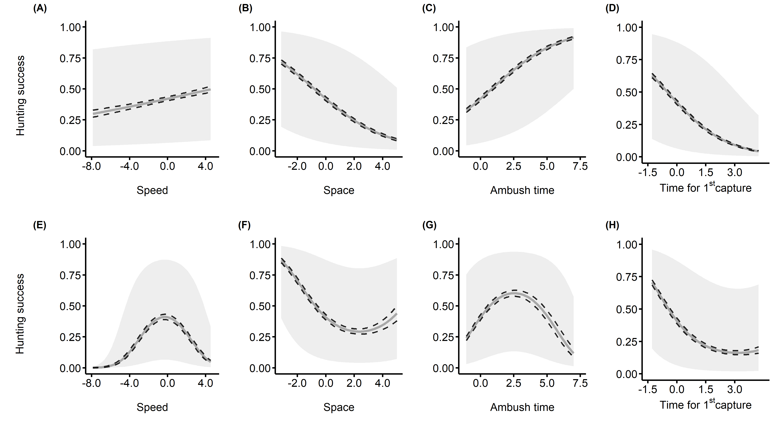

**Figure 3:** Effect of predator hunting behavior on prey capture. Hunting success (i.e. the probability of capturing four prey) is on the y axis for all panels, and the standardized hunting behavior is on the x axis. The black dashed lines represent the 95% credible intervals for the predicted values, and the gray band represents the 95% prediction intervals (variance in fixed effects + variance in random effects). (A), (B), (C), (D) Linear functions. (E), (F), (G), (H) Quadratic functions.

## Effect of predator and prey behaviour on hunting success: predator and prey behavioural interaction

According to our predictions, faster predators were more successful when they competed against sedentary prey (figure 4A). Predators had higher hunting success for the whole range of values of space covered when they competed against slower-moving prey (figure 4C). Contrary to our expectations, the most successful predators where those who covered space at a slow rate when they competed against prey that were slower at covering space in the environment (figure 4D). However, those who covered space at the fastest rate where more successful against prey that were the slowest at covering space (figure 4D). There were no significant interactions between predator and prey travel speed (figure 4B). Lastly, for the whole range of time spent ambushing prey, predators had generally higher success against slower moving prey and prey that covered less space in the environment (figure 4E-F), although the interaction with prey space covered was not significant (table I).

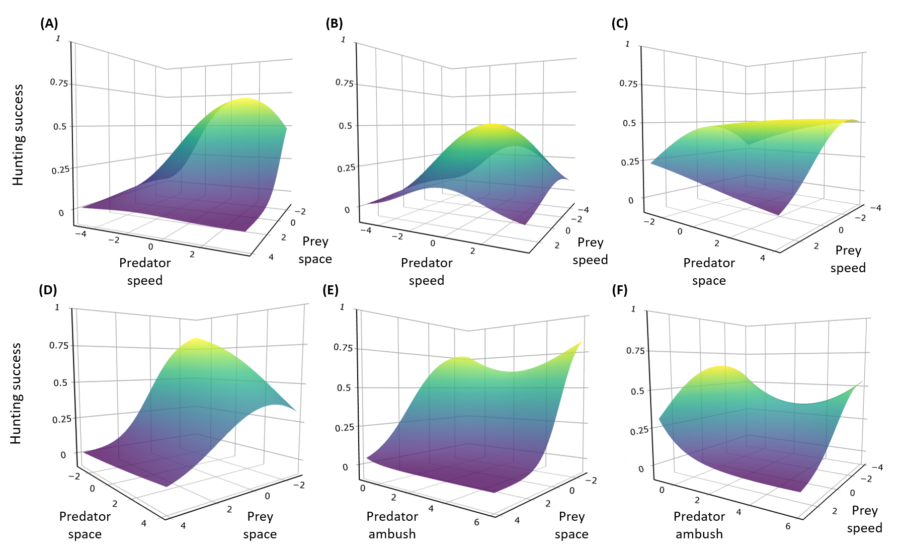

**Figure 4:** Influence of the predator and prey behavioral interactions on predator hunting success. The plots’ 3D surfaces show the relationship between different combinations of predator-prey behaviors and predator hunting success. We fitted the surfaces by predicting the mean probability of capturing four prey based on the best quadratic approximation of the predator and prey interaction terms. Here, we show interactions that enable us to determine if there are predator-prey locomotor crossovers. (A) Predator travel speed and prey space coverage. (B) Predator and prey travel speed. (C) Predator space coverage and prey travel speed. (D) Predator and prey space coverage. (E) Predator time spent ambushing and prey space coverage. (F) Predator time spent ambushing and prey travel speed.

# Discussion

Our study uses an online multiplayer videogame to investigate individual variation in predator foraging mode, and how predator and prey behavior affect hunting success. We provide evidence that individuals who adopt the predator role display individual specialization and flexibility in their foraging modes, varying along a continuum from cursorial to sit-and-wait. The expression of these foraging modes was consistent with shifts in the expression of other behaviors such as space use and the latency to first prey capture, matching the predictions of the foraging syndrome hypothesis at the individual level. Contrary to our expectations, neither hunting behavior nor prey capture varied among game environments. Even if we found the presence of competing foraging modes in the population, the most successful predators were those who hunted at average population values of travel speed, and those who spent an above population-average of their time ambushing prey. Lastly, we found evidence for the locomotor-crossover hypothesis for some predator-prey trait combinations. However, predators were generally less successful when they competed against fast traveling prey and those who covered space faster in the environment.

Our analyses revealed that predators differed in their average travel speed and in their proportion of time spent ambushing prey. These behaviors were negatively correlated at the among-individual level, suggesting that individuals may specialize as either cursorial or ambush predators. Cursorial predators displayed a shorter latency to first prey capture compared to ambush predators. These results are similar to those of McGhee et al. (2013), who found that fast moving northern pike (*Esox lucius*) were quicker to launch their initial attack. Interestingly, we found that hunting success decreased significantly with increasing latency to first capture, but did not strongly interact with time spent ambushing to affect hunting success. Thus, although ambush predators displayed a longer latency to capture their first prey, they were as successful as cursorial predators.

Since individuals achieved similar hunting success across the study period, our observations suggest that ecological mechanisms such as locomotor-crossovers may favor the coexistence of both foraging strategies within the *DBD* predator population. Indeed, we found that cursorial predators had greater hunting success when they competed against more sedentary prey, which agrees with empirical studies that tested the locomotor crossover hypothesis (Belgrad and Griffen 2016; Donihue 2016; Chang et al. 2017). However, locomotor-crossovers did not seem to explain the success of ambush predators, as they also displayed higher success against sedentary prey, or prey travelling at speeds close to the population average. In addition, predators reached similar hunting success across the observed range of space coverage and time spent ambushing (figure 4. C-F). A potential explanation is that by focusing solely on prey speed and space coverage, we failed to capture other important prey strategies involved in the predator-prey interaction. For instance, unpublished results by Santostefano et al. found four prey behavioral profiles in *DBD*, where faster and exploratory individuals seemed distinct from bolder individuals that performed more cooperative/altruistic actions, and that were involved in longer chases with the predator. Hence, we can hypothesize that the success of ambush predators might be explained, to a degree, by a higher capture of bold prey.

Predators also displayed flexibility in their foraging mode, where individuals switched between a cursorial or ambush strategy from one match to the other. These foraging mode switches were accompanied by shifts in space coverage and in latency before a first capture, suggesting that predators may adjust their behavior according to the type of prey encountered. Thus, the outcome of the predator-prey interaction might not only be determined by the individual predator’s preferred hunting mode, but also by its flexibility from one encounter to the next (McGhee et al. 2013). Although this falls outside the scope of this study, further analyses will need to investigate the dynamics of the predator behavior within a match to determine if predators switch between sit-and-wait to cursorial strategies as prey density is reduced (Inoue and Marsura 1983). Short-term switches in hunting mode are also expected to occur as predators make behavioral adjustments in response to prey antipredator behavior (Helfman 1990), and should be favored when prey encounters are unpredictable (Woo et al. 2008; Carneiro et al. 2017; Phillips et al. 2017). Comparing prey selection and capture rates between specialist and flexible hunters could provide important insight into the community-consequences of behavioral decisions made by predators.

An unexpected result in our study was that predator hunting mode did not change across different environments. This contrasts with studies showing that predators exploit habitat characteristics such as vegetation density to choose their hunting strategies (James and Heck Jr. 1994; Warfe and Barmuta 2004; Wasiolka et al. 2009). A potential explanation is that habitat structure may have instead affected prey behavior, for instance, by altering their perception of predation risk or fear (Heithaus et al. 2009; Gaynor et al. 2019). Features of heterogeneous habitats can sometimes exert stronger predator cues, leading prey to avoid these habitats, or alter their activity to reduce predation risks (Preisser et al. 2007). In a seperate analysis, we found that predator space coverage was largely explained by differences among game environments when prey behavior was excluded from the model (table SII, Supporting information), although the variance among game environments for the other traits remainded the same. The observed differences in space coverage among the game environments were also not largely explained by differences in game environment surface area (table SII, Supporting information). Alternatively, it could be that the absence of environmental variance in predator behavior was caused by prey individuals differing in the way they respond to habitat changes, as some could have increased activity in heterogeneous habitats by exploiting refuges, thus, negating the effect of the environment on the predator’s hunting strategy (Warfe and Barmuta 2004). This could also explain why hunting success was similar among game environments. Another explanation is that predators could have altered their hunting behavior at larger scales according to prey behavior, but seek prey accessibility at finer scales by killing them in specific areas (Hopcraft et al. 2005). Ultimately, we cannot exclude the possibility that the game’s design might not properly simulate real ecological habitats to affect the predator’s behavior. For instance, one feature of the game’s design is that predators have constant visual cues on the location of patches where prey forage. This offers them the opportunity to approximate the distance/time required to travel among patches, while possibly relaxing the energy/concentration allocated to managing movement across the habitat’s features. Thus, further investigation is required to properly understand the scale at which the environment shapes predator behavior in this particular system.

We are among the first ecologists (Cere et al. accepted; Barbe et al. 2020) to propose the use of online multiplayer videogames to investigate how ecological mechanisms shape the dynamics of trophic interactions. We are persuaded that videogames are poised to play a central role in testing ecological hypotheses, as they reduce financial, statistical or logistical hurdles associated with empirical research while providing complex and ecologically-relevant datasets. However, videogames are not a panacea and they come with their own biases. Perhaps the most important one is that player behavior may not properly reflect behavioral decisions made by real-life organisms in the wild, as the player cannot “die” (Oultram 2013). Hence, individuals may take greater risks in a videogame compared to real predators (Lofgren and Fefferman 2007; Oultram 2013). Moreover, while *DBD* provides an interesting system to investigate predator-prey interactions, prey density is fixed at four players, which prevents the modelling of predator functional responses. Lastly, similar to mesocosm experiments with single predators, the game may not reflect natural systems where multiple predator species compete for the same prey. In light of these potential biases, researchers should interpret results from online videogames with care, and aim to test specific ecological hypotheses when using virtual systems.

To conclude, individual variation in predator (and prey) behavior is increasingly recognized as a critical factor influencing the outcome of trophic interactions (Pettorelli et al. 2015; Toscano et al. 2016; Moran et al. 2017). Albeit our study being essentially descriptive, as it is the first to investigate individual variation in predator foraging behavior using an online videogame, we showed that individuals differed in contrasting hunting strategies that align with those used by wild predators. These hunting modes varied among- and within- individuals along correlated behaviors (foraging syndrome hypothesis), and our results suggest that predator-prey locomotor-crossovers may promote the coexistence of different predator and prey behavioral types. We are confident that further studies using online videogames will provide valuable ecological insight for behavioral and community ecologists.

# Acknowledgements:

We thank behavior Interactive for generous access to their data, and members of the Rover Team (Julien Céré, Guillaume Bergerot, Jean-Baptise Le Meur, Nicholas Robitaille) in the company for inputs on the preliminary results. We would also like to thank members of the GRECA at UQAM for their insightful comments and suggestions on the whole research process. Lastly, we thank two anonymous reviewers whose comments helped us improve this manuscript. This project was funded by the Mitacs Accelerate Grant (#IT12054) through a partnership with behavior Interactive and Université du Québec à Montréal.

# Competing interests:

The authors declare no competing interests

# Data availability statement:

We could not openly share the data on open science/data web platforms due to ownership and privacy restrictions. However, upon request, we will provide the data used to conduct our analyses. In addition, the project’s R scripts and results are freely available on this GitHub repository: <https://github.com/quantitative-ecologist/videogame_hunting_tactics-Rscripts>.

# Literature Cited

Ahmad, M. A., C. Shen, J. Srivastava, and N. Contractor. 2014. On the Problem of Predicting Real World Characteristics from Virtual Worlds. Pages 1–18 *in* M. A. Ahmad, C. Shen, J. Srivastava, and N. Contractor, eds. Predicting Real World Behaviors from Virtual World Data, Springer Proceedings in Complexity. Springer International Publishing, Cham.

Araújo, M. S., D. I. Bolnick, and C. A. Layman. 2011. The ecological causes of individual specialisation. Ecology Letters 14:948–958.

Arthur, B., M. Hindell, M. N. Bester, W. C. Oosthuizen, M. Wege, and M.-A. Lea. 2016. South for the winter? Within-dive foraging effort reveals the trade-offs between divergent foraging strategies in a free-ranging predator. Functional Ecology 30:1623–1637.

Balicer, R. D. 2007. Modeling Infectious Diseases Dissemination Through Online Role-Playing Games. Epidemiology 18:260–261.

Barbe, L., C. Mony, and B. W. Abbott. 2020. Artificial Intelligence Accidentally Learned Ecology through Video Games. Trends in Ecology & Evolution 35:557–560.

Belgrad, B. A., and B. D. Griffen. 2016. Predator–prey interactions mediated by prey personality and predator hunting mode. Proceedings of the Royal Society B: Biological Sciences 283:20160408.

Bowen, W. D., D. Tully, D. J. Boness, B. M. Bulheier, and G. J. Marshall. 2002. Prey-dependent foraging tactics and prey profitability in a marine mammal. Marine Ecology Progress Series 244:235–245.

Brodie, E. D., A. J. Moore, and F. J. Janzen. 1995. Visualizing and quantifying natural selection. Trends in Ecology & Evolution 10:313–318.

Butler, M. A. 2005. Foraging mode of the chameleon, Bradypodion pumilum: A challenge to the sit-and-wait versus active forager paradigm? Biological Journal of the Linnean Society 84:797–808.

Bürkner, P.-C. 2017. Brms: An R Package for Bayesian Multilevel Models Using Stan. Journal of Statistical Software 80:1–28.

Carneiro, A. P. B., A.-S. Bonnet-Lebrun, A. Manica, I. J. Staniland, and R. A. Phillips. 2017. Methods for detecting and quantifying individual specialisation in movement and foraging strategies of marine predators. Marine Ecology Progress Series 578:151–166.

Carter, A. J., W. E. Feeney, H. H. Marshall, G. Cowlishaw, and R. Heinsohn. 2013. Animal personality: What are behavioural ecologists measuring? Biological Reviews 88:465–475.

Chang, C.-c., H. Y. Teo, Y. Norma-Rashid, and D. Li. 2017. Predator personality and prey behavioural predictability jointly determine foraging performance. Scientific Reports 7:40734.

Cooper, W. E. 2005. The foraging mode controversy: Both continuous variation and clustering of foraging movements occur. Journal of Zoology 267:179–190.

Courbin, N., A. Besnard, C. Péron, C. Saraux, J. Fort, S. Perret, J. Tornos, et al. 2018. Short-term prey field lability constrains individual specialisation in resource selection and foraging site fidelity in a marine predator. Ecology Letters 21:1043–1054.

Dall, S. R. X., and S. C. Griffith. 2014. An empiricist guide to animal personality variation in ecology and evolution. Frontiers in Ecology and Evolution 2:3.

Dingemanse, N. J., and N. A. Dochtermann. 2013. Quantifying individual variation in behaviour: Mixed-effect modelling approaches. Journal of Animal Ecology 82:39–54.

Dingemanse, N. J., and J. Wright. 2020. Criteria for acceptable studies of animal personality and behavioural syndromes. Ethology 126:865–869.

Donihue, C. M. 2016. Aegean wall lizards switch foraging modes, diet, and morphology in a human-built environment. Ecology and Evolution 6:7433–7442.

Gaynor, K. M., J. S. Brown, A. D. Middleton, M. E. Power, and J. S. Brashares. 2019. Landscapes of Fear: Spatial Patterns of Risk Perception and Response. Trends in Ecology & Evolution 34:355–368.

Gerritsen, J., and J. Strickler. 1977. Encounter probabilities and community structure in zooplankton: A mathematical model. Journal of the Fisheries Board of Canada 34.

Glaudas, X., K. L. Glennon, M. Martins, L. Luiselli, S. Fearn, D. F. Trembath, D. Jelić, et al. 2019. Foraging mode, relative prey size and diet breadth: A phylogenetically explicit analysis of snake feeding ecology. Journal of Animal Ecology 88:757–767.

Griffen, B. D., B. J. Toscano, and J. Gatto. 2012. The role of individual behavior type in mediating indirect interactions. Ecology 93:1935–1943.

Harrison, X. A. 2015. A comparison of observation-level random effect and Beta-Binomial models for modelling overdispersion in Binomial data in ecology & evolution. PeerJ 3:e1114.

Heithaus, M. R., L. M. Dill, and J. J. Kiszka. 2018. Feeding strategies and tactics. Pages 354–363 *in* B. Würsig, J. G. M. Thewissen, and K. M. Kovacs, eds. Encyclopedia of Marine Mammals (Third Edition). Academic Press.

Heithaus, M. R., A. J. Wirsing, D. Burkholder, J. Thomson, and L. M. Dill. 2009. Towards a predictive framework for predator risk effects: The interaction of landscape features and prey escape tactics. Journal of Animal Ecology 78:556–562.

Helfman, G. S. 1990. Mode selection and mode switching in foraging animals. Pages 249–298 *in* P. J. B. Slater, J. S. Rosenblatt, and C. Beer, eds. Advances in the Study of Behavior (Vol. 19). Academic Press.

Hertel, A. G., P. T. Niemelä, N. J. Dingemanse, and T. Mueller. 2020. A guide for studying among-individual behavioral variation from movement data in the wild. Movement Ecology 8.

Hopcraft, J. G. C., A. R. E. Sinclair, and C. Packer. 2005. Planning for success: Serengeti lions seek prey accessibility rather than abundance. Journal of Animal Ecology 74:559–566.

Huey, R. B., and E. R. Pianka. 1981. Ecological consequences of foraging mode. Ecology 62:991–999.

Inoue, T., and T. Marsura. 1983. Foraging strategy of a mantid, Paratenodera angustipennis S.: Mechanisms of switching tactics between ambush and active search. Oecologia 56:264–271.

James, P. L., and K. L. Heck Jr. 1994. The effects of habitat complexity and light intensity on ambush predation within a simulated seagrass habitat. Journal of Experimental Marine Biology and Ecology 176:187–200.

Kersch‐Becker, M. F., B. B. Grisolia, M. J. O. Campos, and G. Q. Romero. 2018. Community-wide responses to predation risk: Effects of predator hunting mode on herbivores, pollinators, and parasitoids. Ecological Entomology 43:846–849.

Kobler, A., T. Klefoth, T. Mehner, and R. Arlinghaus. 2009. Coexistence of behavioural types in an aquatic top predator: A response to resource limitation? Oecologia 161:837–847.

Laurel, B. J., and J. A. Brown. 2006. Influence of cruising and ambush predators on 3-dimensional habitat use in age 0 juvenile Atlantic cod Gadus morhua. Journal of Experimental Marine Biology and Ecology 329:34–46.

Lima, S. L. 2002. Putting predators back into behavioral predator–prey interactions. Trends in Ecology & Evolution 17:70–75.

Lofgren, E. T., and N. H. Fefferman. 2007. The untapped potential of virtual game worlds to shed light on real world epidemics. The Lancet Infectious Diseases 7:625–629.

McCoy, E. D., and S. S. Bell. 1991. Habitat structure: The evolution and diversification of a complex topic. Pages 3–27 *in* S. S. Bell, E. D. McCoy, and H. R. Mushinsky, eds. Habitat Structure: The physical arrangement of objects in space, Population and Community Biology Series. Springer Netherlands, Dordrecht.

McGhee, K. E., L. M. Pintor, and A. M. Bell. 2013. Reciprocal behavioral plasticity and behavioral types during predator-prey interactions. The American Naturalist 182:704–717.

McLaughlin, R. L. 1989. Search modes of birds and lizards: Evidence for alternative movement patterns. The American Naturalist 133:654–670.

Michel, M. J., and M. M. Adams. 2009. Differential effects of structural complexity on predator foraging behavior. Behavioral Ecology 20:313–317.

Miles, D. B., J. B. Losos, and D. J. Irschick. 2007. Morphology, performance, and foraging mode. Pages 49–93 *in* D. B. Miles, L. B. McBrayer, and S. M. Reilly, eds. Lizard Ecology. Cambridge University Press, Cambridge.

Miller, J. R. B., J. M. Ament, and O. J. Schmitz. 2014. Fear on the move: Predator hunting mode predicts variation in prey mortality and plasticity in prey spatial response. Journal of Animal Ecology 83:214–222.

Montiglio, P.-O., D. Garant, D. Thomas, and D. Réale. 2010. Individual variation in temporal activity patterns in open-field tests. Animal Behaviour 80:905–912.

Moran, N. P., B. B. M. Wong, and R. M. Thompson. 2017. Weaving animal temperament into food webs: Implications for biodiversity. Oikos 126:917–930.

Nakagawa, S., and I. C. Cuthill. 2007. Effect size, confidence interval and statistical significance: A practical guide for biologists. Biological Reviews 82:591–605.

Nakagawa, S., P. C. D. Johnson, and H. Schielzeth. 2017. The coefficient of determination R2 and intra-class correlation coefficient from generalized linear mixed-effects models revisited and expanded. Journal of The Royal Society Interface 14:20170213.

Nakagawa, S., and H. Schielzeth. 2010. Repeatability for Gaussian and non-Gaussian data: A practical guide for biologists. Biological Reviews 85:935–956.

Niemelä, P. T., and N. J. Dingemanse. 2014. Artificial environments and the study of “adaptive” personalities. Trends in Ecology & Evolution 29:245–247.

Oultram, S. 2013. Virtual plagues and real-world pandemics: Reflecting on the potential for online computer role-playing games to inform real world epidemic research. Medical Humanities 39:115–118.

Perry, G. 1999. The evolution of search modes: Ecological versus phylogenetic perspectives. The American Naturalist 153:98–109.

Perry, G., Y. L. Werner, I. Lampl, D. Rothenstein, N. Sivan, A. Lerner, and E. Shani. 1990. Foraging mode in lacertid lizards: Variation and correlates. Amphibia-Reptilia 11:373–384.

Pettorelli, N., A. Hilborn, C. Duncan, and S. M. Durant. 2015. Chapter Two - Individual variability: The missing component to our understanding of predator–prey interactions. Pages 19–44 *in* S. Pawar, G. Woodward, and A. I. Dell, eds. Advances in Ecological Research, Trait-Based Ecology - From Structure to Function (Vol. 52). Academic Press.

Phillips, R. A., S. Lewis, J. González-Solís, and F. Daunt. 2017. Causes and consequences of individual variability and specialization in foraging and migration strategies of seabirds. Marine Ecology Progress Series 578:117–150.

Preisser, E. L., J. L. Orrock, and O. J. Schmitz. 2007. Predator hunting mode and habitat domain alter nonconsumptive effects in predator–prey interactions. Ecology 88:2744–2751.

Robinson, S. K., and R. T. Holmes. 1982. Foraging behavior of forest birds: The relationships among search tactics, diet, and habitat structure. Ecology 63:1918–1931.

Romero, G. Q., and J. Koricheva. 2011. Contrasting cascade effects of carnivores on plant fitness: A meta-analysis. Journal of Animal Ecology 80:696–704.

Ross, T. L., E. Castronova, and I. Knowles. 2015. Virtual Worlds as Laboratories. Pages 1–15 *in*Emerging Trends in the Social and Behavioral Sciences. American Cancer Society.

Sargeant, B. L., A. J. Wirsing, M. R. Heithaus, and J. Mann. 2007. Can environmental heterogeneity explain individual foraging variation in wild bottlenose dolphins (Tursiops sp.)? Behavioral Ecology and Sociobiology 61:679–688.

Scharf, I., E. Nulman, O. Ovadia, and A. Bouskila. 2006. Efficiency evaluation of two competing foraging modes under different conditions. The American Naturalist 168:350–357.

Schmitz, O. 2017. Predator and prey functional traits: Understanding the adaptive machinery driving predator–prey interactions. F1000Research 6:1767.

Schmitz, O. J. 2008. Effects of predator hunting mode on grassland ecosystem function. Science 319:952–954.

Smith, B. R., and D. T. Blumstein. 2010. Behavioral types as predictors of survival in Trinidadian guppies (Poecilia reticulata). Behavioral Ecology 21:919–926.

Tinker, M. T., G. Bentall, and J. A. Estes. 2008. Food limitation leads to behavioral diversification and dietary specialization in sea otters. Proceedings of the National Academy of Sciences 105:560–565.

Toscano, B. J., N. J. Gownaris, S. M. Heerhartz, and C. J. Monaco. 2016. Personality, foraging behavior and specialization: Integrating behavioral and food web ecology at the individual level. Oecologia 182:55–69.

Toscano, B. J., and B. D. Griffen. 2014. Trait-mediated functional responses: Predator behavioural type mediates prey consumption. Journal of Animal Ecology 83:1469–1477.

Warfe, D. M., and L. A. Barmuta. 2004. Habitat structural complexity mediates the foraging success of multiple predator species. Oecologia 141:171–178.

Wasiolka, B., N. Blaum, F. Jeltsch, and J. Henschel. 2009. Behavioural responses of the lizard Pedioplanis l. Lineoocellata to overgrazing. Acta Oecologica 35:157–162.

Wignall, A. E., and P. W. Taylor. 2008. Alternative predatory tactics of an araneophagic assassin bug (Stenolemus bituberus). Acta Ethologica 12:23.

Wirsing, A. J., M. R. Heithaus, J. S. Brown, B. P. Kotler, and O. J. Schmitz. 2021. The context dependence of non-consumptive predator effects. Ecology Letters 24:113–129.

Wolf, M., and F. J. Weissing. 2012. Animal personalities: Consequences for ecology and evolution. Trends in Ecology & Evolution 27:452–461.

Woo, K. J., K. H. Elliott, M. Davidson, A. J. Gaston, and G. K. Davoren. 2008. Individual specialization in diet by a generalist marine predator reflects specialization in foraging behaviour. Journal of Animal Ecology 77:1082–1091.